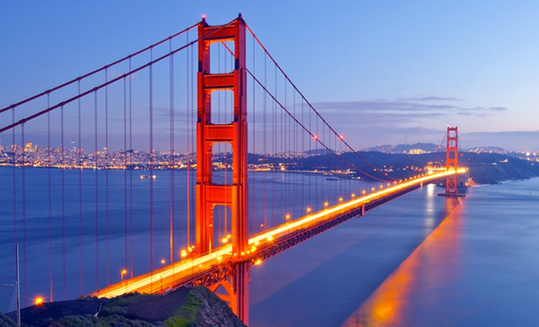

AdventureTime California Tour Guide

Tips & Tricks: California is the third largest state in the country. Filled with forest’s, beaches, deserts, and mountains. When visiting these areas, it is important to protect yourself from the harsh rays of light with some sunscreen. Also remember to dress appropriately when adventuring in the outdoors. California’s most problematic natural disasters are Earthquakes. When traveling to California, travelers should know how to properly handle a situation if an Earthquake were to happen. Another natural disaster that has been occurring frequently in California is wildfires. Areas in California can be very dry and easily flammable, be extremely cautious when lighting any kind of fire. This is definitely optional, but tipping is a common gesture when dining out in California.

Must Visit Places : Golden Gate Bridge in San Francisco, Yosemite National Park, Disneyland in LA, Joshua Tree National Park

Must Try Dining: Hog Island Oyster Co., In n Out, Koi Palace, Park’s BBQ

Brown Sugar Kitchen, Benu